Monthly Performance Report – May 2026
Kestrel Ridge Wind Farm (75.6 MW)
David Chen · 09 June 2026 · KR-OPS-RPT-2026-05

1. Summary
Kestrel Ridge generated 13.6 GWh in May 2026, 4.9 % below the P50 budget of 14.3 GWh. Availability fell to 96.8 %, below the contract target of 97.0 %. Mean hub-height wind speed of 7.4 m/s was close to the long-term mean (7.3 m/s). Compared with May 2025 (14.2 GWh), output was down 0.6 GWh.
T-12 ISS bearing replaced up-tower between 12 and 15 May (preventive, no crane required). The removed bearing showed axial cracks consistent with the T-07 failure mode.

2. Production and key figures
KPI | May 2026 | Budget / target | YTD 2026 | YTD budget
Net generation (GWh) | 13.6 | 14.3 | 95.6 | 99.0
Time-based availability | 96.8 % | 97.0 % | 96.5 % | 97.0 %
Capacity factor | 24.2 % | 25.4 % | 34.9 % | –
Mean wind speed at hub height (m/s) | 7.4 | 7.3 | – | –
Source: Kestrel Ridge SCADA, revenue meter at 132 kV point of connection. Budget = P50 (2024 post-construction yield assessment).
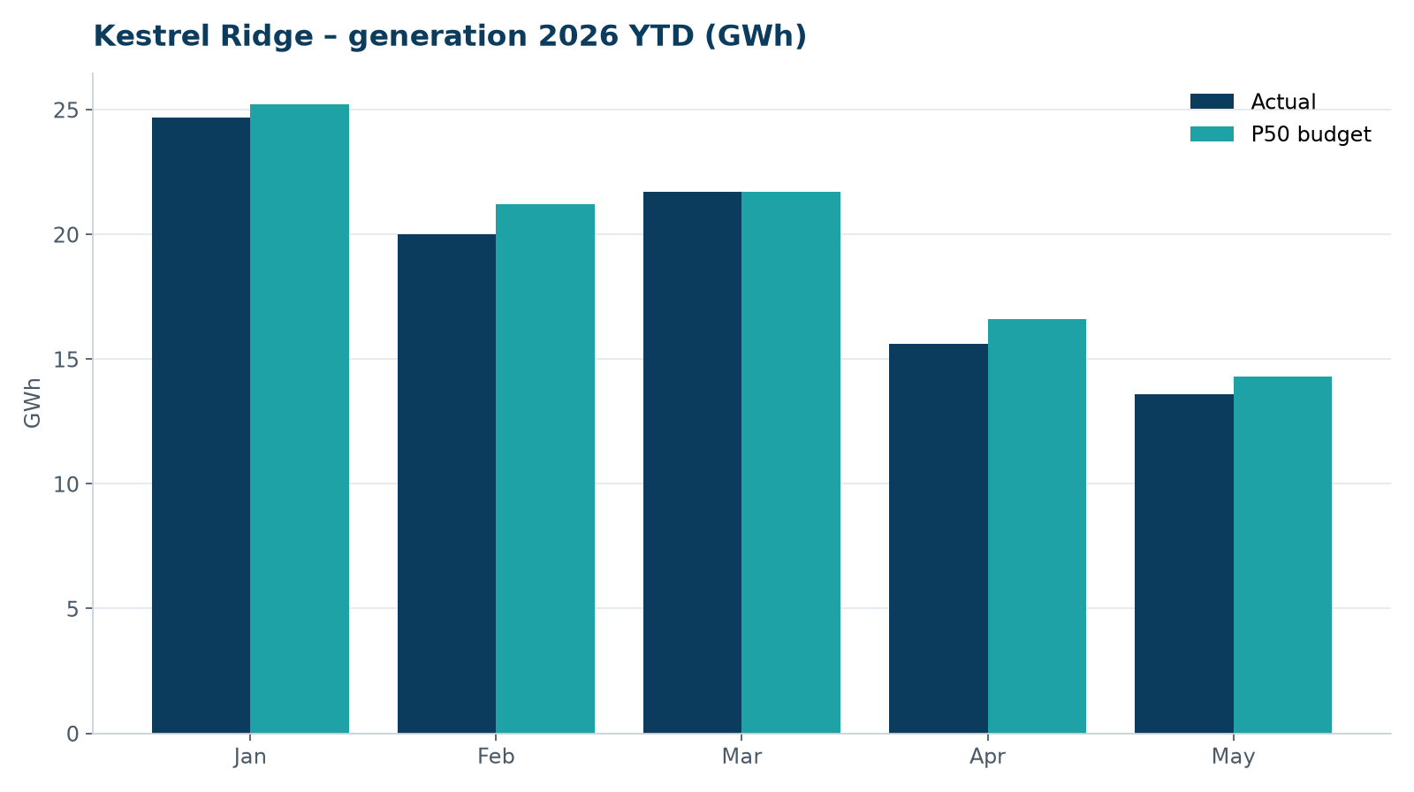
Monthly generation vs. P50 budget, 2026 year to date

3. Availability and downtime
Total turbine downtime attributable to the contractor amounted to 137 turbine-hours for the top events listed below. No grid or force majeure exclusions were claimed this month.
Turbine | Event | Downtime (h)
T-12 | planned up-tower ISS bearing replacement (preventive) | 85
T-14 | hydraulic oil leak at rotor brake caliper | 16
T-05 | pitch motor encoder fault on blade A | 15
T-18 | generator slip ring brush wear alarm | 11
T-10 | service lift fault – lift locked out, turbine stopped for rescue cover | 10
Top downtime events of the month (SCADA event log, reviewed with Highline Wind Services).

4. Maintenance
- Annual service: 4 turbines completed this month.
- 22 corrective work orders closed, 4 still open at month end.
- Gearbox oil samples taken on six turbines as per the quarterly rota; results within limits.

5. Health, safety and environment
Indicator | Month
Hours worked on site (Highline + Weyland) | 4,210
Lost time injuries | 0
First aid cases | 0
Near misses reported | 0
Safety observations | 10
Environmental incidents | 0

No complaints from neighbours were received this month.

6. Outlook
The P50 budget for next month assumes normal seasonal wind; no planned outages beyond routine maintenance.
Prepared by Sara Lindgren (Performance Analyst); reviewed by Ben Okoye (Site Manager) and David Chen (Asset Operations Manager).

